

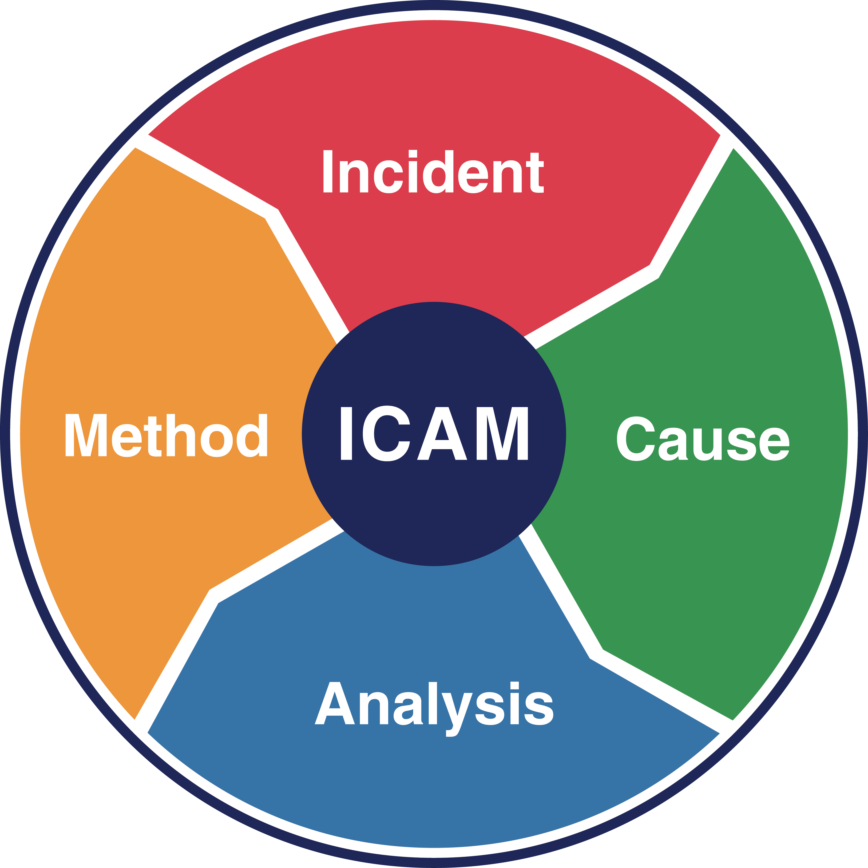
Ver [No.] [Date]

Prepared for the sole purpose preventing a reoccurrence within the workplace. Confidential and subject to limited distribution.

Note: Replace this statement (front cover & footer) if under LPP.
Example - Commissioned by [Law Firm] for the sole purpose of providing legal advice - subject to legal professional privilege and confidential - not to be distributed to third parties without the explicit permission of [Law Firm] and the [Name of Organisation].
Prepared by [Investigator]
INCIDENT INVESTIGATION REPORT into
[Name of Incident Investigation]

CONTENTS OF REPORT

1.0 Introduction 3
2.0 Scope of Investigation 3
3.0 Methodology 4
4.0 Investigation Team 4
5.0 Incident Description 5
5.1 Incident Details 5
5.2 Background 6
5.3 Events Leading up to the Incident 6
5.4 Incident Event 6
5.5 Events Post Incident 6
5.6 Time Line 7
6.0 Photographs / Diagrams 8
7.0 Data Collection 9
7.1 People 9
7.1.1 [Header] Example: Supervision and Work Instructions 9
7.1.2 [Header] Example: Role, Training, and Experience 9
7.1.3 [Header] 9
7.1.4 Other Factors 9
7.1.5 Conclusions 10
7.2 Environment 10
7.2.1 [Header] Example: Plant Process Operating Conditions 10
7.2.2 [Header] 10
7.2.3 Conclusions 10
7.3 Equipment 10
7.3.1 [Header] Example: Earth Moving Equipment 10
7.3.2 [Header] 10
7.3.3 Conclusions 10
7.4 Procedures 10
7.4.1 [Header] Example: Process and Application 10
7.4.2 [Header] 10
7.4.3 [Header] 11
7.4.4 Conclusions 11
7.5 Organisation 11
7.5.1 [Header] Example: Procedures and Risk Management 11
7.5.2 [Header] Example: Roles and Responsibility 11
7.5.3 [Header] 11
7.5.4 Conclusions 11
8.0 Key Findings 11
8.1 Basic Cause 11
8.2 Contributing Factors 11
8.2.1 Absent or Failed Defences 11
8.2.2 Individual or Team Actions 12
8.2.3 Task or Environmental Condition 12
8.2.4 Organisational Factors 12
9.0 Recommendations 12
9.1 [Header] [(Control Type)] 12
9.2 [Header] [(Control Type)] 12
9.3 [Header] [(Control Type)] 13
9.4 [Header] [(Control Type)] 13
9.5 [Header] [(Control Type)] 13
10.0 Management Review of the Investigation Report 13
10.1 Management Review 13
10.1.1 Distribution 13
10.1.2 Implementation of Corrective Actions 13
10.1.3 Implementation Monitoring 13
10.1.4 Analyse Effectiveness 13
10.1.5 Document Archival 13
11.0 Significant Learnings 14
11.1 [Header] 14
11.2 [Header] 14
11.3 [Header] 14
12.0 Appendices 15
12.1 [Header] 15
12.2 [Header] 16
12.3 ICAM Analysis 17
12.4 Corrective Action Plan 18
13.0 Report Sign-off 19

Introduction
In [Month] [Name of Organisation], who provide [description of services and where], engaged HSE International Group Limited to investigate a significant incident which [Description of incident and where].
Example:
In November 2019 Looney Maintenance, who provide industrial services to the Looney Gas Fields and Facilities in the Sedimentary Basin owned by ACME Limited (ACME), engaged HSE International Group Limited to investigate a significant incident where four employees undertook work without proper LOTO processes being followed.

Scope of Investigation
The scope of work required a quality and systemic investigation methodology using the Incident Cause Analysis Method (ICAM) to determine the contributing factors to the [description of the incident] by identifying deficiencies, if any, within the organisation’s systems and processes. The focus of the investigation is at an organisational systems level and includes both cultural and behavioural aspects, if applicable, where operational discipline to the application of process may, or may not, have contributed to the incident.

As directed by [name of Client] this investigation delivers the following outcomes that:

- establish the facts surrounding the incident.
- identify the underlying causes and latent hazards.
- include review of the adequacy of existing controls and procedures.
- recommend corrective actions required to prevent recurrence, reduce risk around the activity taking place at the time of the incident and promote safety within [name of Client].
- meet relevant Statutory and [Name of Organisation] requirements for incident investigation and reporting; and
- present the findings, following the completion of the investigation, using the HSEI International Investigation Report format.

Example 1 first paragraph:
The scope of work required a quality and systemic investigation methodology using the Incident Cause Analysis Method (ICAM) to determine the contributing factors to the unapproved use of a light vehicle by Looney personnel by identifying deficiencies, if any, within the organisation’s systems and processes. The focus of the investigation is at an organisational systems level and includes both cultural and behavioural aspects, if applicable, where operational discipline to the application of process may, or may not, have contributed to the incident.
Looney have also initiated an internal human resources (HR) investigation into this incident. This investigation report should be read in conjunction with the HR investigation report.

Example 2 first paragraph:
The scope of work required a quality and systemic investigation methodology using the Incident Cause Analysis Method (ICAM) to determine contributing factors to the failure of the HP feed side port coupling by identifying deficiencies, if any, within the organisation’s systems and processes. The focus of the investigation is at an organisational systems level and does not cover the technical elements to determine the failure analysis mode of the coupling, and/or its components, associated with the safe operation of the reverse osmosis process that have, or may have, contributed to the incident.

A previous similar incident (ID: 01467312) occurred at the ACME Desalination Plant on 27 July 2020. The investigation was conducted by ACME personnel and the investigation report was provided as part of the data sources for this investigation. As part of this investigation, the report is to be reviewed for effectiveness and appropriateness of the data collected and analysed, corrective actions, and learnings and influence these had on this latest incident. This Report should be read in conjunction with any technical failure investigation report/s provided to ACME in relation to this incident and the previous incident investigation report for the incident occurring on 27 July 2020.

Methodology
The methodology to conduct this investigation aligned to the principles of the ICAM using the following steps which included:

- Data Collection and Data Organisation to determine contributing factors.
- Data Analysis of the contributing factors.
- Corrective Actions to address the contributing factors.
- Key Learnings for [Name of Organisation].

In conducting this investigation, the following processes and techniques were applied.

- Provision of an independent incident investigation technical expert (Lead Facilitator) providing advice to the investigation team leader nominated by [Name of Client].
- Site appointed members to the investigation team.
- Site visit. Note - may be a remote investigation
- Communication of the scope and intent of the investigation to key stakeholders to gain support via a pre-investigation meeting and post-site visit meeting with [Name of Client] management.
- Obtain complete access to people for either interviews and/or discussions.
- Obtain complete access to documentation, equipment, computer process data, CCTV footage, and voice recordings relevant to the incident that will assist in the investigation.
- Allow access for taking of photographs relevant to the incident.

On completion of the investigation, the Lead Facilitator provided a draft report, using the HSEI Investigation Report format, to [Name of Client] for review and comment prior to delivering this final Report.

Investigation Team

Name | Position | Company
 | ICAM Lead Facilitator (independent) | HSE International

5.0 Incident Description

Incident Details
Note: The incident details in the following tables may vary from incident to incident. Delete what is not relevant and insert additional category descriptors, if required, that provide important relevant information.

Brief Description:
Location: | Area:
Incident Date: Time:
Report Date: Time:
Notification to Client:
Client Incident Number:
Incident Type:
Details of Entities
Client (Owner of Assets):
Contractor:
Details of Person/s Involved
Name: Role: Employer:
Name: Role: Employer:
Name: Role: Employer:
Injuries Sustained:
Supervisor and Manager
Name: Role: Employer:
Name: Role: Employer:

Details of Vehicle / Damage
Vehicle:
Damage:
Environmental Impact:
Risk Ranking - Severity / Consequence Level
Actual Ranking:
Potential Ranking:

The risk ratings above were assessed using the Incident Severity Classification Chart in the [Organisation] Incident Management Procedure, Document No. [No.]
Background

Events Leading up to the Incident

Incident Event

Events Post Incident

Timeline
[Date, time]
[Event description]
[Time]
[Event description]

Pre-incident Events

Incident

[Date, Time]
[Incident event description]
[Date, time]
[Event Description]

Post-incident Events

Figure .1 - Time line summary of events

Photographs / Diagrams

Figure 2: [Description].

Figure 3: [Description].

Figure 4: [Description].

7.0 Data Collection
Data was gathered to identify the relevant facts surrounding the incident using the principles, techniques, and methodology of the ICAM Data Collection process focusing on the five data categories known as the “PEEPO” process. These five data categories are:

- People.
- Environment.
- Equipment.
- Procedures, and
- Organisation

The basis of the data collection is to establish details of the incident and determine the contributing and non-contributing factors to the incident.

People
The personnel associated with the incident and/or activities and process impacting on the incident occurring on [Date] were interviewed providing statements and/or were subject to discussions. These personnel are detailed in Table below.

Name | Position | Company

[Header] Example: Supervision and Work Instructions

[Header] Example: Role, Training, and Experience

[Header]

Other Factors

Conclusions
[Detail the ‘People’ contributing factors]

Environment
The environmental conditions were identified to understand the conditions in place at the time of the incident. These conditions are details in the following:

[Header] Example: Plant Process Operating Conditions

[Header]

Conclusions
[Detail the ‘Environment’ contributing factors]

Equipment
The equipment involved at the time of the incident included…

[Header] Example: Earth Moving Equipment

[Header]

Conclusions
[Detail the ‘Equipment’ contributing factors]

Procedures
The [Name of Organisation] processes and procedures relating to [description of incident] were reviewed to establish any aspects that may have contributed to the incident. The following documents were reviewed which include:

- [Document Title and Number]
- [Document Title and Number]
- [Document Title and Number]

[Header] Example: Process and Application

[Header]

[Header]

Conclusions
[Detail the ‘Procedures’ contributing factors]

Organization
[Name of Organisation] systems and processes impacting on the task at the time of the incident are included in the following:

[Header] Example: Procedures and Risk Management

[Header] Example: Roles and Responsibility

[Header]

Conclusions
[Detail the ‘Organisation’ contributing factors].

8.0 Key Findings
The key findings outline why the incident occurred and the contributing factors identified from the investigation are categorised using the Incident Cause Analysis Method (ICAM). The ICAM analysis chart is shown as an Appendix, Section 12 of this report.

Basic Cause
The basic cause of the incident was…
This basic cause combining with the following contributing factors led to the incident.

Contributing Factors
Based on the evidence to hand, the following were the main contributing factors to the incident:

Note: All codes assigned to the contributing factors are detailed in the HSE International Pocket Investigation Guide; pages 38 to 41.

Absent or Failed Defenses

- [Code and Description]
- [Code and Description]
- [Code and Description]
- [Code and Description]

Individual or Team Actions

- [Code and Description] Example Personal Optimizing Violation
- [Code and Description] Example Routine Violation
- [Code and Description] Example Rule-based Mistake

Task or Environmental Condition

- [Code and Description]
- [Code and Description]
- [Code and Description]
- [Code and Description]

Organizational Factors

- [Code and Description]
- [Code and Description]
- [Code and Description]
- [Code and Description]

9.0 Recommendations
The following recommended corrective actions are proposed for consideration. The recommendations address the Absent or Failed Defences and Organisational Factors identified as key findings of the investigation. These recommendations are applicable to the Business Group or site and could benefit other [Name of Organisation] operations.

[Header] Example Control Type

[Header] Example Control Type

[Header] Example Control Type

[Header] Example Control Type

10.0 Management Review of the Investigation Report

Management Review
The management of the Business Group, site and Project should formally review the investigation report for completeness, quality of the investigation and to endorse the recommendations with aligned corrective actions. It is recommended that the following action plan is implemented:

Distribution
To maximise the preventative potential of the investigation report, the findings and conclusions of the report should be distributed as widely as practicable internally within [Name of Organisation] Business Groups and externally to industry bodies.

Implementation of Corrective Actions
Corrective actions addressing the recommendations shall be formally presented to the Responsible Line Manager for implementation. An action plan and timeframe shall be agreed and endorsed by the appropriate level of management. An action plan is attached in Appendix, Section 12 of this report.

Implementation Monitoring
The completion of corrective actions must be documented and communicated by the Responsible Line Manager to the Site Senior Executive, and in turn to the Safety Manager. Where corrective actions have not been fully implemented, ongoing monitoring should be maintained until implementation is complete.

Analyze Effectiveness
The effectiveness of the corrective actions should be evaluated by a review of safety performance and through an audit within the next six months whereby a report will be prepared for management to detail compliance and progress achieved.

Document Archival
Investigative data and reports shall be archived in accordance with site and regulatory requirements.

11.0 Significant Learnings
The investigation has raised several key learnings which are covered in the body of the report.
The significant learnings for [Name of Organisation] are:

[Header]

[Header]

[Header]

12.0 Appendices

[Header]
[Reference material that supports the body of report]

ICAM Analysis
The features of the ICAM chart for the purposes of this Report are:

- It provides a graphical representation of all the key circumstances and factors relating to the incident; and
- It outlines the relationship of the various elements considered throughout this report.

In addition, ICAM is designed to:

- Provide a framework to organise the data collected.
- Assist in assuring the investigation follows a logical path.
- Aid in the resolution of conflicting information and the identification of missing data, and
- Provide a diagrammatical display of the investigative process for management briefing.

Accordingly, this ICAM table should not be considered in isolation and needs to be considered in the context of all the investigation findings and comments in this report.

Analysis Chart
Note: Refer to Section 8, Key Findings of this Report for additional details and the description of the codes assigned to the contributing factors.

Corrective Action Plan
To be completed in consultation with [Name of Organisation] line management and approved by management to determine the appropriate corrective actions, from the recommendations provided, for the business.

Item Ref | Recommendation |  | Responsible  Department | Responsible Person | Completion  Date | Sign off
9.1
9.2
9.3
9.4
9.5
General Manager’s Close out of Incident - All corrective actions have been completed, where corrective actions have not been fully implemented, the following measures have been put in place to ensure ongoing monitoring until implementation is complete.
Name: |  | Signature: |  |  | Date:

13.0 Report Sign-off
To maximise the preventative potential of the investigation report, the findings and conclusions of the report should be distributed to the various people involved in the incident and as widely as practicable.
The completion of corrective actions must be documented and communicated by the Responsible Line Manager to the Site Senior Executive, and in turn to the Safety Manager. Where corrective actions have not been fully implemented, ongoing monitoring should be maintained until implementation is complete.

Feedback to the Involved Person(s) and comments:
Name: | Signature: | Date:
Feedback to the Involved Person(s) Supervisor(s) and comments:
Name: | Signature: | Date:
Department Manager’s acceptance of findings and comments:
Name: | Signature: | Date:
Safety Manager’s acceptance of findings and comments:
Name: | Signature: | Date:
Site Senior Executive’s acceptance of findings and comments:
Name: | Signature: | Date:

